**Creating Cloud-Watch Alarm for Lambda Function**:-

* Go to the Lambda Service and Copy the given Lambda function   
  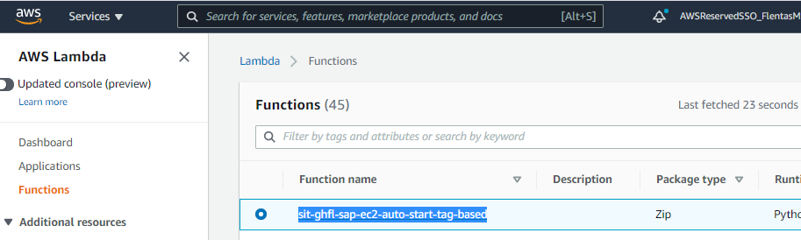

Step-2.) Go to Cloud-Watch service and check Lambda fuction is already present or not. If function is already exists then no need to do anything and If function is not there then Clcik on “Create Fucntion”  


Step-3.) Clcik on Select Matrix   
  
Step-4.) Paste the Lambda Fucntion in search bar and hit enter  
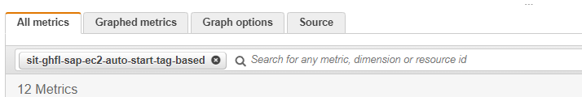

Step-5.) Click on Lambda by function search for Error(for error matrix only) or Throttle (for throttle matriz only) Matrix:-  
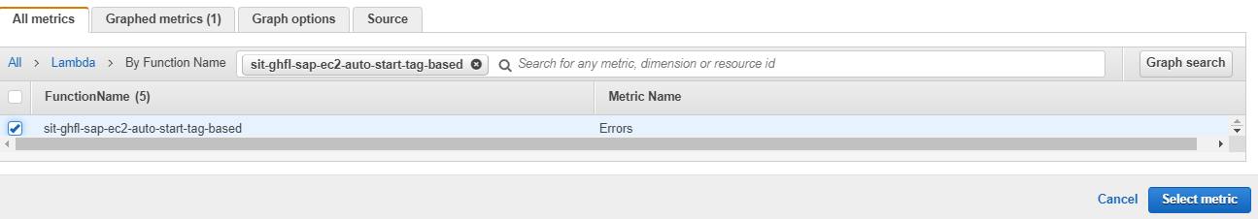  
Step 6.) Select Period 1 min:-  
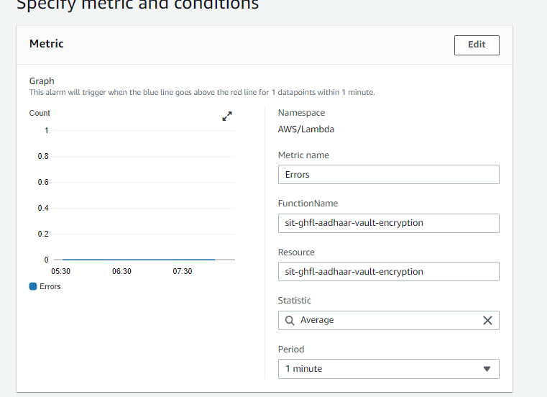

Step 7.) Select Greater/Equal =1   
 DataPoints to Alarm :- 4/5  
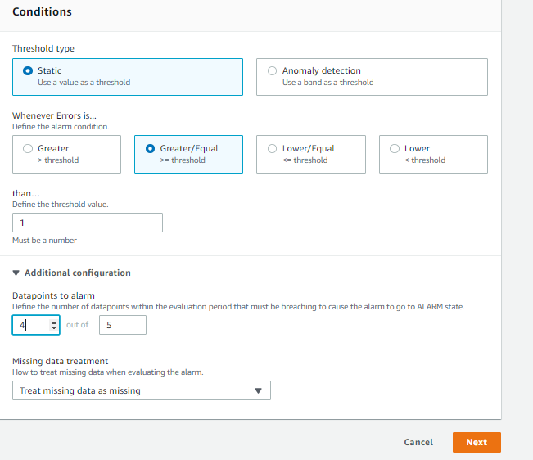  
  
Step-8.) Confirm the SNS topic from Team member or Check from other alarm  
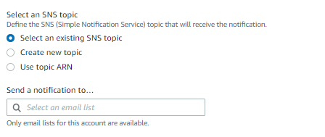

Step-9) Given Lambda function name and description carefully  
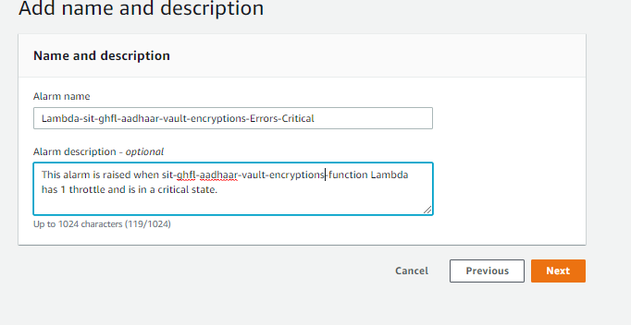

Ste-10.) Click on Next  
  
Step-11.) Same way to do it for Throttle Matrix  
 Select on Throttle matix check out from Step-5.